31.43: a)
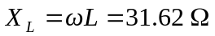; 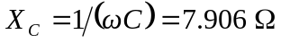
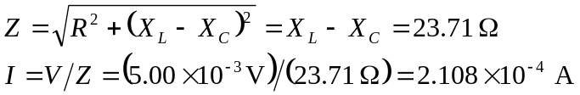
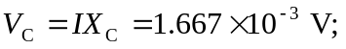 this is the maximum voltage across the capacitor.
b) In part (a) we found I = 0.211 mA
c) 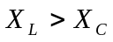 and R = 0 gives that the source and inductor voltages are in phase; the voltage across the capacitor lags the source and inductor voltages by 